ЗАЯВКА НА ФИНАНСИРОВАНИЕ ГУМАНИТАРНОГО ПРОЕКТА

1. | Наименование проекта | «Фантазия»
2. | Наименование организации | Государственное учреждение образования «Новолукомльская детская школа искусств»  Чашникского района, Витебской области, Республика Беларусь.
3. | Физический и юридический адрес организации, телефон, факс е-mail | ул. Набережная,13 211162, г.Новолукомль, Витебская обл.  тел. 8021 33 5 79 31, факс. 8021 33 6 75 16  e-mail: NDSHI@TUT.BY
4. | Информация об организации | Государственное учреждение образования «Новолукомльская детская школа искусств»  В настоящее время в структуре школы насчитывается один филиал в а\г. Лукомль.
5. | Руководитель организации | Демидчик Александр Николаевич, директор, тел.  8 02133 6 75 16
6. | Менеджер проекта | Мацкевич Зося-Наталья Викторовна, заведующая филиалом, тел. 8 02133 3 79 31
7. | Прежняя помощь, полученная от других иностранных источников | нет
8. | Требуемая сумма | 47 000.00 $
9. | Софинансирование | Собственные средства – 100.00 $
10. | Срок проекта | сентябрь 2019 года - август 2020 года
11. | Цель проекта | - приобретение знаний и навыков детей дошкольного возраста в различных видах художественного творчества;  - выявление и гармоничное развитие творческих способностей;  - создание условий для реализации творчества, познание мира искусства.
12. | Задачи проекта | - создание условий для улучшения качества подготовки детей к школе;  - выявление одарённых детей.  - создание благоприятного эмоционального климата;  - развитие всесторонней личности,  - развитие воображения.  - приобщение детей к творчеству;  - освоение современных подходов и технологий к развитию ребёнка;  - обучение методами, направленными на психоэмоциональное развития детей;  - вовлечение детей в активную творческую деятельность через искусство.  - отвлечение детей от чрезмерного использования гаджетов.
13. | Детальное описание деятельности в рамках проекта в соответствии с поставленными задачами | Краткое описание мероприятий в рамках проекта:  1. Создание кабинетов «студия «Фантазия»».  1.1. Оснащение помещений мебелью.  1.2. Приобретение материалов, инструментов, наглядной агитации, музыкальных инструментов для организации деятельности.  1.3. Проведение мастер-классов для учителей.  1.4. Участие в выставках и концертных программах.  1.5. Организация работы по развитию творческих способностей.  2. Создание комнат для занятия живописью, хореографией и музыкальный кабинет.  2.1. Оснащение инструментарием комнат для хореографии, музыки и художественного творчества.  2.2. Проведение занятий.  3. Оформление наглядной агитацией кабинетов.  3.1. Приобретение инвентаря для занятий декоративно-прикладным творчеством.  3.2. Посещение профессиональных выставок и концертов.  Целевая группа:  - дети дошкольного возраста 4-7 лет.  Количество участников: Ежегодно около 100 детей дошкольного возраста.  Ожидаемые результаты: приобретение знаний и навыков в различных видах художественного творчества; воспитание посредством созерцания, укрепление физического и психоэмоционального здоровья; отвлечение детей от гаджетов. Творчество.  Ответственное лицо: Мацкевич Зося-Наталья Викторовна, заведующая филиалом.
14. | Обоснование проекта | Одним из приоритетных направлений государственной политики Республики Беларусь является улучшение демографической ситуации в стране. Важной составляющей в решении этой проблемы является всесторонняя развитая личность. В настоящее время одной из самых социально важных групп населения в Республике Беларусь являются дети дошкольного возраста. С раннего детства у детей проблема гаджетов, потребительское отношение к жизни. Низкий уровень жизненной активности может привести подростка к разочарованию в своей неподготовленности к взрослой жизни, невостребованность, которая зачастую приводит к суициду. Для детей дошкольного возраста очень важно почувствовать всю красоту бытия через призму искусства, а затем, приобретя определённые навыки, творить и созидать самостоятельно на благо себе, стране и всему человечеству.  Особенно данная проблема видна в малых населенных пунктах, где сегодня дети не могут позволить себе посетить высокого уровня выставки, культурные мероприятия, которые могут увлечь детей и приобщить к творчеству. Типичным у нас стало пьянство не только мужчин, но и женщин. Налицо необходимость привлечения подростков нравственным началам. В городе Новолукомле насчитывается 500 детей дошкольного возраста.  В целях создания условий для преодоления пассивного бытия подрастающего поколения и усиления влияния искусства посредством обеспечения доступности образовательных, досуговых услуг, объединения их в группы по интересам, создания условий на удовлетворение духовных и социокультурных потребностей, детей дошкольного возраста, подготовке к самостоятельной жизни.  Находясь в самой школе искусств дети уже соприкасаются с искусством.
15. | Деятельность после окончания проекта | Улучшение качества воспитания детей дошкольного возраста посредством творческой деятельности и формирование у данной категории чувства социального благополучия, оптимистического настроения, ощущения востребованности и нужности на протяжении всей жизни, творческого долголетия. Приобщение детей к художественным ценностям посредством культурных и образовательных программ. Оказание детям морально-психологической поддержки, чтобы дать им уверенность в завтрашнем дне, наполнить их жизнь смыслом, способностью творить, а не вытворять, сделать жизнь яркой и интересной.  Проект позволит одарённым детишкам продлить учёбу в школе искусств по выбранной специальности, повысит мотивацию и заинтересованность в решении своих жизненно важных проблем, даст знания в понимании искусства, даст возможность участвовать и творить. Все это в конечном итоге повысит уровень интеллекта ребёнка и ему намного легче будет усвоить и другие знания.
16. | Бюджет проекта | 1.МЕРОПРИЯТИЕ: Создание кабинета «Фантазия»  Собственные ресурсы: Людские ресурсы  Запрашиваемые ресурсы:  Кабинеты 3 штук Х 600.00=1800.00  Косметический ремонт:  Краска для пола 5 банок Х 16.00 = 80.00  Подоконники 2 шт. Х 100.00 = 200.00  Обои 10 трубок Х 40.00= 400.00  Краска для шкафов и радиаторов 5 банок Х 15 =75.00  Жалюзи 5шт. Х 200.00 = 1000.00  Стенды 4 шт. Х 100.00 = 400.00  Оснащение помещения мебелью:  Комплект мебели (стол, стулья, шкафы) 1 Х 7000.00 = 7000.00  Итого: 10955.00  Приобретение материалов, инструментов, изделий, музыкальных инструментов, костюмов для организации деятельности, направленной на обучение:  Собственные ресурсы: Людские ресурсы  Принадлежности для рукоделия: ткань лён, клей ПВА, фурнитура, деревянные рамки, нитки, иголки, карандаши, альбомы для рисования, кисти ножницы - 1000.00  Итого: 1000.00  Запрашиваемые ресурсы:  Ткань для рукоделия 500 м Х 10.00 = 5000.00  Костюмы сценические 16 шт. Х 400.00 = 6400.00  Аккордеон цифровой клавишный 1 шт. Х 7000.00 = 7000.00 Итого: 18400.00  Проведение мастер-классов для целевой группы.  Собственные ресурсы: Людские ресурсы  Принадлежности для мастер-классов: ленты атласные, клей, фурнитура, нитки, иголки, шпагат - 400.00  Кофе-пауза:  Чай 3 упаковки Х 3.00 = 9.00  Сахар 4 кг Х 1.50 =6.00  Печенье 9 кг Х 6.00 =54.00  Конфеты 6 кг Х 8.00 =48.00  Итого: 517.00  Запрашиваемые ресурсы:  Флип-чарт 1 шт. Х 125.00 = 125.00 Итого: 125.00  Участие в выставках, концертных программах.  Собственные ресурсы: Людские ресурсы  Транспортные расходы - 200.00  Итого: 200.00  Запрашиваемые ресурсы:  Выставочная витрина 1 шт. Х 200.00 = 200.00  Автобус, школьный. Х 55.637 = 55.637 Итого: 55837.00  2.МЕРОПРИЯТИЕ:  Создание комнат.  Запрашиваемые ресурсы:  Замена пола в хореографии 2шт. Х 1000.00=2000.00  Косметический ремонт:  Краска для пола 2 банки Х 16.00 = 32.00  зеркала 10 шт. Х 40.00 = 400.00  Итого: 2432.00  Оснащение инструментарием комнаты.  Запрашиваемые ресурсы:  Комплект мебели (столы, стулья) 1 Х 2000.00 = 2000.00  мальберты 16шт. Х 100.00 = 1600.00  Панно 1 шт. Х 180.00 = 180.00  Стол на ножках для рисования песком 1 шт. Х 450.00 = 450.00  Кварцевый песок для рисования 1 шт. Х 40.00 = 40.00 Итого: 4670.00  Проведение музыкальных уроков.  Собственные ресурсы: Людские ресурсы  компьютер – 1000.00  Игрушечные музыкальные инструменты  10 Х 10.00= 100.00  Итого: 1100.00  3.МЕРОПРИЯТИЕ:  Проведение хореографических мероприятий  Собственные ресурсы:Людские ресурсы  Запрашиваемые ресурсы:  Коврики 10 шт. Х 30.00=300.00  табуретки 10 шт. Х 30 =300.00  Костюм для занятий 10 шт. Х 20.00 = 200.00 Итого: 800.00  ИТОГО: 94 836 белорусских.рублей
Комната «художественная»

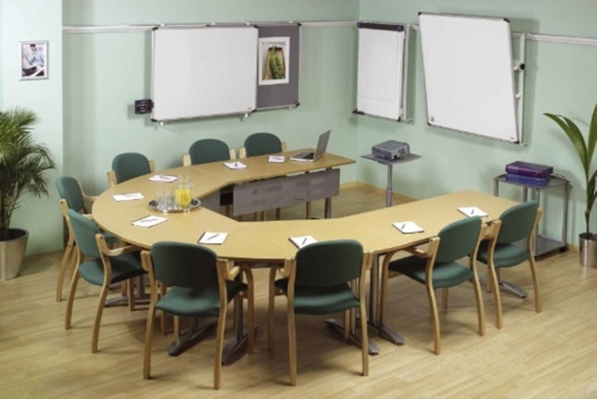

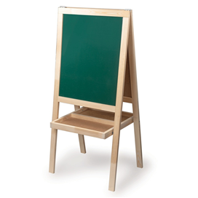

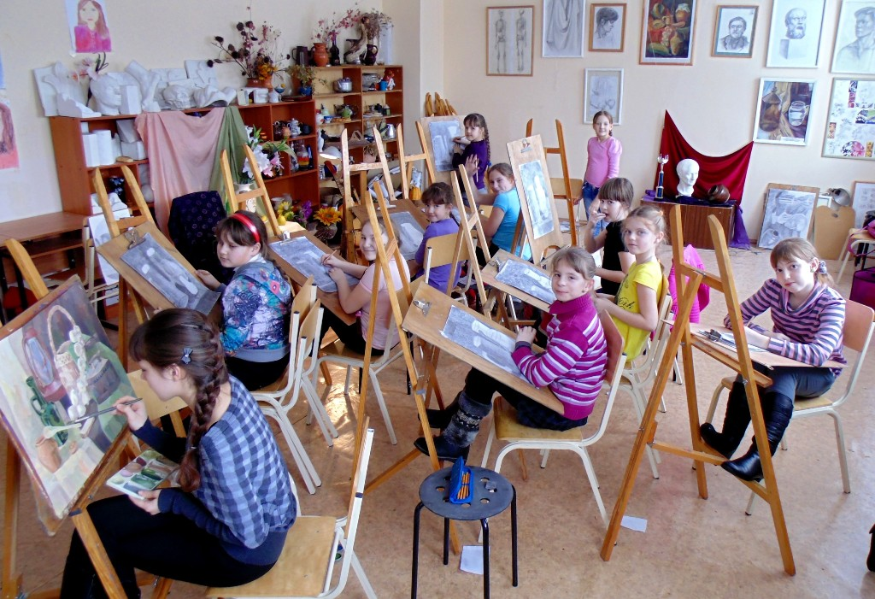

комната хореографии

Музыкальная комната

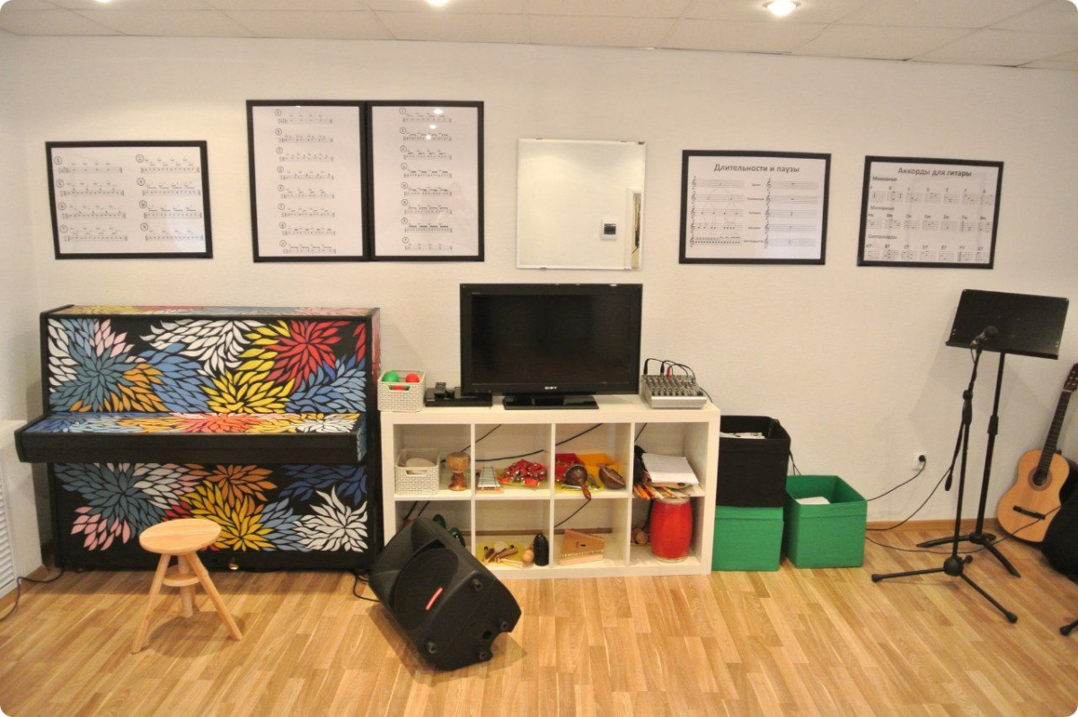

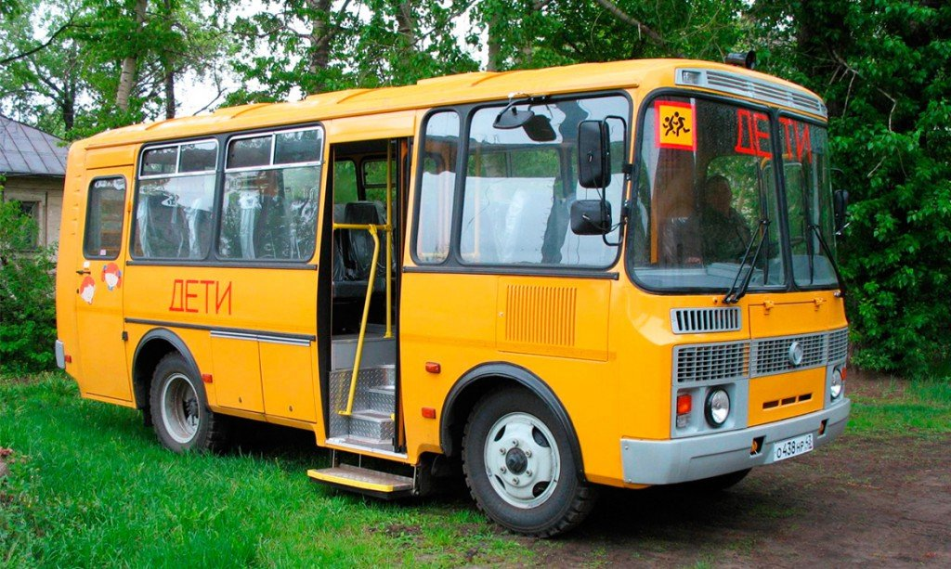Школьный автобус

APPLICATION FOR FINANCING A HUMANITARIAN PROJECT
1. | name of the project | Name of the project “Fantasy”
2. | Name of company | Name of organization State educational institution "Novolukoml children's art school"
3. | Physical and legal address of the organization, phone, fax e-mail | Chashniki district, Vitebsk region, Republic of Belarus.
4. |  | Information about the organization Public institution of education "Novolukoml children's art school"
5. | Organization Information | Head of the organization Demidchik Alexander Nikolaevich, Director, tel.  8 02133 6 75 16
6. | Head of the organization | Project Manager Mackevich Zosja, branch teacher, tel. 8 02133 3 79 31
7. | Project manager | no
8. | Previous assistance received from other foreign sources | Amount Required $ 47,000.00
9. | Amount Required | Co-financing Own funds - $ 100.00
10. | Co-financing | Project term September 2019 - August 2020
11. | Project term | The purpose of the project is the acquisition of knowledge and skills of preschool children in various types of art.  - Identification and harmonious development of creative abilities.  - Creation of conditions for the implementation of creativity, knowledge of the art world.
12. | Project objectives | Project objectives - creating conditions for improving the quality of preparation of children for school;  - identification of gifted children.  - creating a favorable emotional climate;  - development of a comprehensive personality,  - development of the imagination.  - introducing children to creativity;  - mastering modern approaches and technologies to the development of the child - training by methods aimed at the psycho-emotional development of children;  - involving children in active creative activity through art.
13. | Detailed description of the project activities in accordance with the tasks | Detailed description of the project activities in accordance with the tasks  Brief description of project activities:  1. Creation of cabinets "Fantasy Studio".  1.1. Equipping premises with furniture.  1.2. The acquisition of materials, instruments, visual agitation, musical instruments for organizing activities.  1.3. Conducting master classes for teachers.  1.4. Participation in exhibitions and concert programs.  1.5. Organization of work on the development of creative abilities.  2. Creation of rooms for painting, choreography and a music room.  2.1. Tooling rooms for choreography, music and art.  2.2. Conducting classes.  3. Design visual agitation cabinets.  3 3.1. Acquisition of equipment for arts and crafts.  3.2. Visiting professional exhibitions and concerts.  Target group:  - Preschool children 4-7 years old.  Number of participants: Annually, about 100 preschool children.  Expected results: the acquisition of knowledge and skills in various types of artistic creation; education through contemplation, strengthening physical and psycho-emotional health; distraction of children from gadgets. Creation..  Responsible person: Zosja Mackevich, branch teacher.
14. |  | Project Justification One of the priority directions of the state policy of the Republic of Belarus is to improve the demographic situation in the country. An important component in solving this problem is a comprehensively developed personality. Currently, one of the most socially important population groups in the Republic of Belarus is children of preschool age. From early childhood, children have the problem of gadgets, consumer attitude to life. A low level of life activity can lead a teenager to disappointment in his unpreparedness for adulthood, lack of demand, which often leads to suicide. For preschool children it is very important to feel the beauty of life through the prism of art, and then, having acquired certain skills, create and create on your own for the benefit of yourself, the country and all of humanity.  This problem is especially visible in small towns, where today children cannot afford to attend high-level exhibitions, cultural events that can captivate children and introduce them to creativity. Typical of us was drinking not only men but also women. There is a need to attract moral adolescents. In the city of Novolukoml, there are 500 preschool children.  In order to create conditions for overcoming the passive life of the younger generation and enhancing the influence of art by ensuring the availability of educational and leisure services, uniting them into interest groups, creating conditions for satisfying spiritual and sociocultural needs, preschool children, and preparing for independent life.  While in the art school itself, children are already in contact with art.  Activities after the end of the project Improving the quality of upbringing of preschool children through creative activity and the formation of a sense of social well-being, optimistic mood, a sense of relevance and need throughout life, creative longevity in this category. Communicating children
15. | Project Justification | mproving the quality of upbringing of preschool children through creative activity and the formation in this category of a sense of social well-being, optimistic mood, a sense of relevance and need throughout life, creative longevity. Familiarizing children with artistic values ​​through cultural and educational programs. Providing children with moral and psychological support in order to give them confidence in the future, to fill their life with meaning, the ability to create, and not to get up, to make life bright and interesting.  The project will allow gifted children to extend their studies at an art school in their chosen specialty, increase motivation and interest in solving their vital problems, provide knowledge in understanding art, and provide an opportunity to participate and create. All this will ultimately increase the child's level of intelligence and it will be much easier for him to learn other knowledge.
16. | Activities after the end of the project | 1. ACTIVITY: Creation of an office “Fantasy”  Own Resources: Human Resources  Requested Resources:  Cabinets 3 pieces X 600.00 = 1800.00  Redecorating:  Paint for the floor 5 cans X 16.00 = 80.00  Window sills 2 pcs. X 100.00 = 200.00  Wallpaper 10 tubes X 40.00 = 400.00  Paint for cabinets and radiators 5 cans X 15 = 75.00  Blinds 5pcs. X 200.00 = 1000.00  Stands 4 pcs. X 100.00 = 400.00  Furnishing a room:  Furniture set (table, chairs, cabinets) 1 X 7000.00 = 7000.00  Total: 10,955.00  The acquisition of materials, instruments, products, musical instruments, costumes for the organization of activities aimed at training:  Own Resources: Human Resources  Needlework accessories: linen fabric, PVA glue, accessories, wooden frames, threads, needles, pencils, sketchbooks, scissors brushes - 1000.00  Total: 1000.00  Requested Resources:  Needlework fabric 500 m X 10.00 = 5000.00  Stage costumes 16 pcs. X 400.00 = 6400.00  Digital keyboard accordion 1 pc. X 7000.00 = 7000.00 Total: 18400.00  Conducting master classes for the target group.  Own Resources: Human Resources  Accessories for workshops: satin ribbons, glue, accessories, threads, needles, twine - 400.00  Coffee pause:  Tea 3 packs X 3.00 = 9.00  Sugar 4 kg X 1.50 = 6.00  Cookies 9 kg X 6.00 = 54.00  Candy 6 kg X 8.00 = 48.00  Total: 517.00  Requested Resources:  Flip chart 1 pc. X 125.00 = 125.00 Total: 125.00  Participation in exhibitions, concert programs.  Own Resources: Human Resources  Shipping costs - 200.00  Total: 200.00  Requested Resources:  Showcase 1 pc. X 200.00 = 200.00  School bus. X 55.637 =  2. EVENT:  Creating rooms.  Requested Resources:  Replacing the floor in choreography 2pcs. X 1000.00 = 2000.00  Redecorating:  Paint for the floor 2 cans X 16.00 = 32.00  mirrors 10 pcs. X 40.00 = 400.00  Total: 2432.00  Tooling room.  Requested Resources:  Furniture set (tables, chairs) 1 X 2000.00 = 2000.00  16 pieces malberts X 100.00 = 1600.00  Panel 1 pc. X 180.00 = 180.00  Table on the legs for painting with sand 1 pc. X 450.00 = 450.00  Quartz sand for drawing 1 pc. X 40.00 = 40.00 Total: 4670.00  Conducting music lessons.  Own Resources: Human Resources  computer - 1000.00  Toy musical instruments  10 X 10.00 = 100.00  Total: 1100.00  3. EVENT:  Carrying out choreographic events  Own Resources: Human Resources  Requested Resources:  Mats 10 pcs. X 30.00 = 300.00  stools 10 pcs. X 30 = 300.00  Suit for classes 10 pcs. X 20.00 = 200.00 Total: 800.00

The room is "art"

choreography room

Music room

School bus

